SQL Assignment 4
Retrieving Information from Tables.
1) Writes a select command that produces the order number,amount, and date for all rows in the Orders tables.
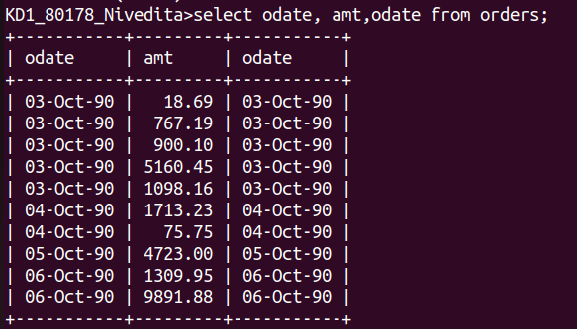
2)Write a query that produces all rows from the customers tables for which the salesperson’s number is 1001.
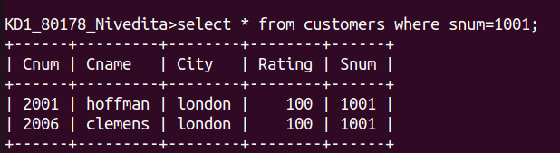

3)Write a query that displays the Salespeople table with the column in the following orders:city,sname,snum,comm.
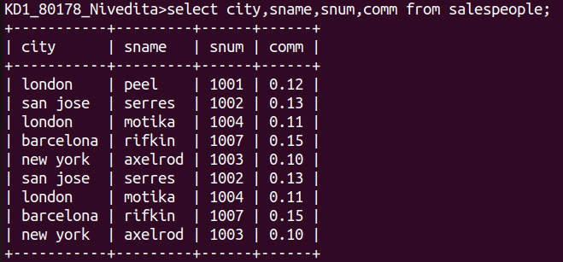
4)Write s select command that produces the rating followed by the name of each customer in San Jose.
